JIM HORNFISCHER

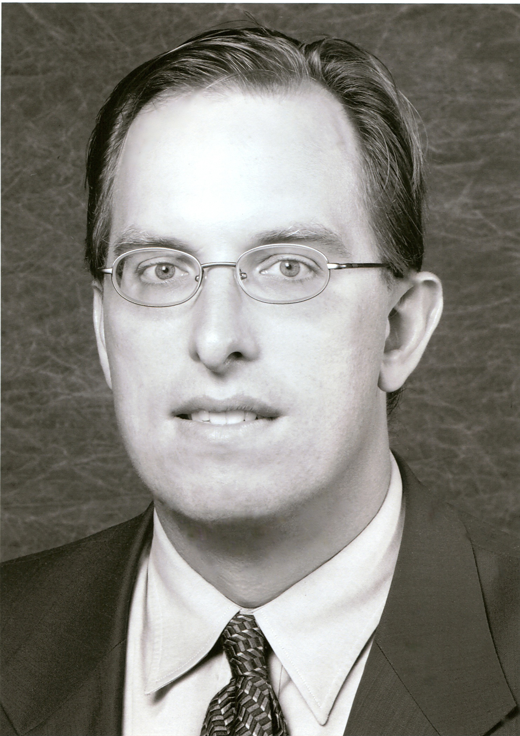
Jim Hornfischer, president of Hornfischer Literary Management, is one of the few agents in the country who is both a licensed attorney and a former New York trade book editor. In sixteen years as an agent, Hornfischer has handled twelve New York Times bestsellers (including two #1's) and several winners of major book prizes.
His clients include George Friedman, author of THE NEXT 100 YEARS: A FORECAST FOR THE 21ST CENTURY, James Bradley, author of FLAGS OF OUR FATHERS, David Mendell, author of OBAMA: FROM PROMISE TO POWER, H. W. Brands, author of TRAITOR TO HIS CLASS: THE PRIVILEGED LIFE AND RADICAL PRESIDENCY OF FRANKLIN DELANO ROOSEVELT, and Ron Powers, author of MARK TWAIN: A LIFE.
Hornfischer began his publishing career in New York in 1987. Prior to becoming an agent in 1993, Hornfischer was an editor at HarperCollins in New York, where he worked on books by authors including Erica Jong, Jared Diamond, Philip Caputo, Erma Bombeck, Yogi Berra, Smokey Robinson, and Ginger Rogers.
A lifelong World War II history buff, he is also the author of two well-received nonfiction books of his own, published by Bantam.

